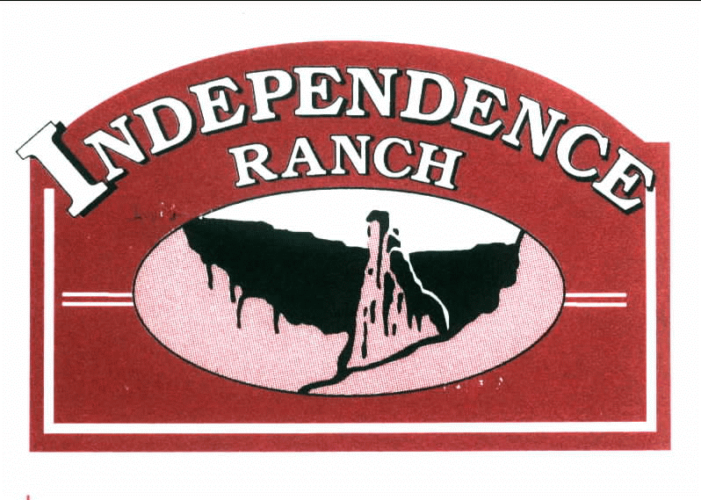

Notice of Annual Meeting

Location: Two Rivers Winery,

2087 Broadway (Rt 340)

Day: Tuesday, November 1, 2022

Time: 6:30 PM Business Meeting first followed by Social time until 8:30 PM.

Agenda
- Year in Review
- Review Financials
- Vote on 2023 Budget (budget included)
- Election of Board Members
- Q&A Session

Drawing for Two Rivers Winery gift certificates.
Cash bar (wine, beer and soda) will be available.

